EXPERIMENT 6

Experiment 6.1 :-

// Declare variables
let name = "Lavkesh"; // string
let age = 20; // number
let isStudent = true; // boolean

// Print variables
console.log("Name:", name);
console.log("Age:", age);
console.log("Is Student:", isStudent);

// Check data types
console.log("Type of name:", typeof name);
console.log("Type of age:", typeof age);
console.log("Type of isStudent:", typeof isStudent);

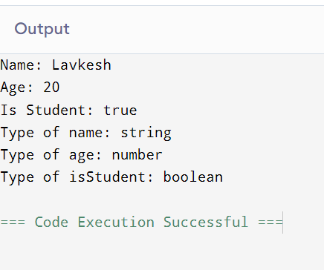

Experiment 6.2 :

// Variables
let a = 15;
let b = 4;

// Arithmetic operations
console.log("a + b =", a + b); // Addition
console.log("a - b =", a - b); // Subtraction
console.log("a * b =", a * b); // Multiplication
console.log("a / b =", a / b); // Division
console.log("a % b =", a % b); // Modulus

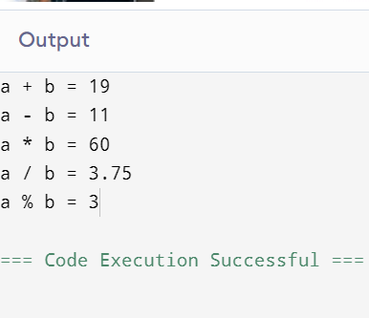

Experiment 6.3 :-
let a = 20;
let b = 5;

let operators = ["+", "-", "*", "/"];

for (let operator of operators) {
let result;
switch (operator) {
case "+":
result = a + b;
break;
case "-":
result = a - b;
break;
case "*":
result = a * b;
break;
case "/":
result = b !== 0 ? a / b : "Error: Division by zero";
break;
default:
result = "Invalid operator";
}
console.log(`${a} ${operator} ${b} = ${result}`);
}

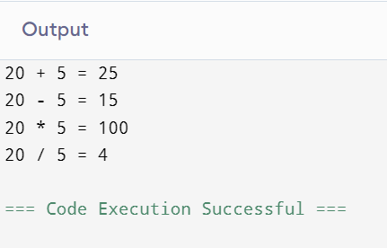
Experiment 6.4 :
let age = prompt("Enter your age:");
age = Number(age);

if (age >= 18) {
console.log("Eligible to vote");
} else {
console.log("Not eligible to vote");
}
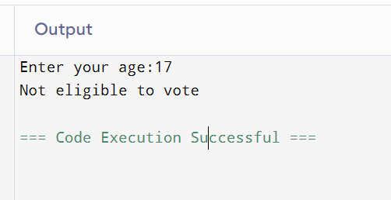
Experiment 6.5 :

let marks = prompt("Enter your marks:");
marks = Number(marks);

if (marks >= 90) {
console.log("Grade A");
} else if (marks >= 75) {
console.log("Grade B");
} else if (marks >= 50) {
console.log("Grade C");
} else {
console.log("Fail");
}

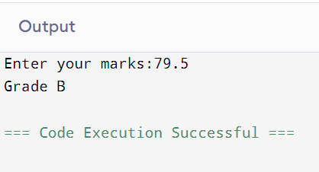

Experiment - 6.6

// 6.6: Day of the Week (user input)
let day = parseInt(prompt("Enter a number (1-7): "));

switch (day) {
case 1: console.log("Monday"); break;
case 2: console.log("Tuesday"); break;
case 3: console.log("Wednesday"); break;
case 4: console.log("Thursday"); break;
case 5: console.log("Friday"); break;
case 6: console.log("Saturday"); break;
case 7: console.log("Sunday"); break;
default: console.log("Invalid day");
}

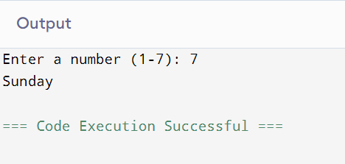

Experiment – 6.7

// For prompt() in browser
// In Node.js, install prompt-sync and replace prompt() with it

// 6.7 (a): Even or Odd
let num = parseInt(prompt("Enter a number: "));
if (num % 2 === 0) {
console.log(num + " is Even");
} else {
console.log(num + " is Odd");
}

// 6.7 (b): Largest of three numbers
let a = parseInt(prompt("Enter first number: "));
let b = parseInt(prompt("Enter second number: "));
let c = parseInt(prompt("Enter third number: "));

if (a >= b && a >= c) {
console.log("Largest is " + a);
} else if (b >= a && b >= c) {
console.log("Largest is " + b);
} else {
console.log("Largest is " + c);
}

